भारत मौसम विज्ञान विभाग |  | India Meteorological Department
Monday 18th May 2026 (28th Vaisakha 1948 Saka)
Summary of observations recorded at 0830 hours IST: Southwest monsoon has further advanced into some more parts of southeast Arabian Sea, some parts of Comorin area, some more parts of southwest and southeast Bay of Bengal, most parts of Andaman Sea, entire Andaman & Nicobar Islands and some parts of eastcentral Bay of Bengal on today, the 18th May 2026. The Northern Limit of Monsoon now passes through 6°N/70°E, 6°N/75°E, 7°N/80°E, 9°N/85°E, 12°N/90°E, 14°N/93°E, 16°N/96°E and 17.5°N/98°E. Conditions are favourable for further advance of southwest monsoon into some more parts of southeast Arabian Sea, Comorin Area, southwest and southeast Bay of Bengal, remaining parts of Andaman Sea, and some more parts of eastcentral Bay of Bengal during next 3-4 days. The Southwest Monsoon is likely to set in over Kerala on 26th May with a model error of ± 4 days.. The Western Disturbance as a cyclonic circulation over north Iran & neighbourhood persisted between 5.8 & 7.6 km above m. s. l.. The upper air cyclonic circulation lay over east Uttar Pradesh lay over northeast Uttar Pradesh & adjoining Bihar and extended upto 1.5 km above m. s. l.The upper air cyclonic circulation lay over northeast Bihar lay over Sub-Himalayan West Bengal & neighbourhood at 0.9 km above m. s. l..The trough ran from the west Madhya Pradesh to South Interior Karnataka across Madhya Maharashtra, Marathawada and North Interior Karnataka and extended upto 1.5 km above m. s. l..An upper air cyclonic circulation lay over south Coastal Andhra Pradesh & neighbourhood between 3.1 & 5.8 km above m. s. l...A trough ran from southeast Arabian Sea adjoining south Lakshadweep area to the above cyclonic circulation over south Coastal Andhra Pradesh across Kerala, South Interior Karnataka and Rayalaseema between 3.1 & 5.8 km above m. s. l...The upper air cyclonic circulation over northeast Tamil Nadu and neighbourhood became less marked.The upper air cyclonic circulation over west Madhya Pradesh and neighbourhood became less marked. The upper air cyclonic circulation west Vidarbha & neighbourhood became less marked.The upper air cyclonic circulation lay over central Assam & neighbourhood became less marked.The upper air cyclonic circulation lay over Comorin Area & neighbourhood became less marked.

Maximum Temperature Departures (as on 17-05-2026): markedly above normal (> 5.1°C) at most places over Himachal Pradesh and West Madhya Pradesh; at few places over East Uttar Pradesh, West Uttar Pradesh and East Madhya Pradesh. appreciably above normal(3.1°C to 5.0°C) at isolated places over Coastal Andhra Pradesh & Yanam. above normal(1.6°C to 3.0°C) at most places over West Rajasthan; at isolated places over Rayalaseema. near normal(-1.5°C to 1.5°C) at most places over Tamil Nadu, Puducherry & Karaikal; at few places over Kerala & Mahe. The highest maximum temperature of 46.4°C was reported at BANDA (UTTAR PRADESH).
Heat wave condition realised over few pockets over Vidarbha and isolated places over West Madhya Pradesh.
Preliminary Earthquake Report: An earthquake shock of Moderate intensity at its origin with epicenter at Lat. 13.163° North and Long. 93.779°East of 205 km above m. s. l. NNE of Port blair; Andaman & Nicobar island , India about 2207 kms away from Pune, was recorded by the seismographs in the meteorological Office Pune at 02 Hrs. 53 Min. 35 Secs. IST on 17-05-2026 having its magnitude 5.3 on the Richter scale.

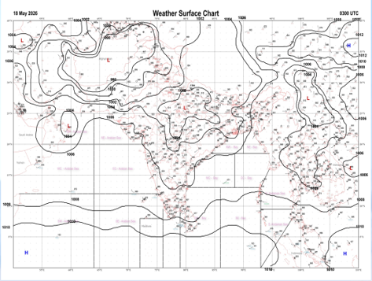 | 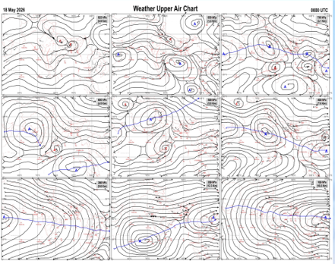
Fig.1. Analysed surface chart based on 03z observation | Fig.2. Analysed upper air chart based on 00z observation
Dr. Sudeep b.l.
Scientist ‘D’
CR & S Office, Pune  Issued at 1245 hrs. IST |  | Weather Forecasting Division  CR&S, Pune

Indian regions | Realised rainfall (chief amount in cm during past 24 hrs):
East | most places: Arunachal Pradesh+  many places: Assam & Meghalaya+, Nagaland-Manipur-Mizoram-Tripura+ and Sub-Himalayan West Bengal & Sikkim+++  isolated places: Gangetic West Bengal, Odisha, Jharkhand and Bihar  Jhallong 19.7, Newlands tea garden 10.7, Lembuchhera 8.2, Khowang 7.3, Badatighat 7.2, Seppa 6.8, Arundhutinagar 6.0, Tadong 5.8, Naharlagun AWS 5.5, Pasighat AP 4.8, Agartala AP 4.6, D / Mohanbari AP 3.4, Sheragada 2.0, Madhabarida 1.9, Parihar 1.5, Pakuria 1.0, Nalhati 0.6, Charaut 0.5, Baripada & Gumla bishnupur kvk AWS 0.4 each, Salar 0.2.
North | dry weather: Uttar Pradesh, Uttarakhand, Haryana, Punjab, Himachal Pradesh, Jammu-Kashmir and Ladakh and Rajasthan
Central | isolated places: east Madhya Pradesh and Chhattisgarh  dry weather: west Madhya Pradesh and Vidarbha  Mainpur 0.8, Gudh 0.5, Rajim 0.4, Huzur 0.1.
Peninsula | most places: Kerala+  many places: coastal Karnataka  a few places: Tamil Nadu+, north interior Karnataka+ and south interior Karnataka  isolated places: Konkan & Goa+, Madhya Maharashtra, Telangana and Rayalaseema  dry weather: Gujarat State, Marathwada and coastal Andhra Pradesh  Kozhikode 10.1, Aralam AWS 9.5, Chinnakalar 9.3, Quilandi 9.1, Gadag PBO 8.3, Quepem 7.8, Ponnaniyar dam 6.0, Yercaud 5.5, Canacona 4.9, Kuppam 4.7, Haliyal 4.3, Hubballi 3.6, Kushtagi 3.3, Kiravatti 3.2, Tyagarthi 2.7, Sargur 2.3, Shivamogga PTO 2.2, Dabolim n.a.s. navy 2.0, Mangaluru AP 1.4, Nandipet 1.2, Chandgad 0.4, Santhipuram 0.3, Ajra & Kohir 0.1 each.
Islands | most places: Andaman & Nicobar  many places: Lakshadweep  Iaf carnicobar 4.0, Long island 3.7, Maya bandar 3.1, Minicoy 1.0, Amini 0.8.
Table-2 Forecast / warnings (distribution of rain / thundershowers) for 7 days (valid from time of origin upto 0830 hrs IST of next day)
Sr N. |  | Sub-division Name | Day 1 | Day 2 | Day 3 | Day 4 | Day 5 | Day 6 | Day 7 | Sr. No. | Sub-division Name | Day 1 | Day 2 | Day 3 | Day 4 | Day 5 | Day 6 | Day 7
 |  |  | 18 May | 19 May | 20 May | 21 May | 22 May | 23 May | 24 May |  |  | 18 May | 19 May | 20 May | 21 May | 22 May | 23 May | 24 May
 | 1 | Andaman Nicobar Islands | W +  | W +  | W + | W+  | W+ | W+  | W +  | 19 | west Madhya Pradesh | D + | D + | D + | D + | D + | D + | D +
 | 2 | Arunachal Pradesh | F +  | S  | S | S | F +  | W ++  | W ++  | 20 | east Madhya Pradesh | D + | D + | D + | D + | D + | D + | D +
 | 3 | Assam-Meghalaya | F +  | S  | S  | S +  | F+ | W ++ | W++ | 21 | Gujarat region | D + | D | D | D | D | D | D
 | 4 | Nagaland-Manipur-Mizoram-Tripura | F ++  | S +  | S  | F  | F+ | F + | F + | 22 | Saurashtra and Kutch | D + | D | D | D | D | D | D
 | 5 | Sub Him West Bengal/Sikkim | F  | S  | F  | W +  | W ++  | W +  | W +  | 23 | Konkan and Goa | I  | I  | I  | I | I | I | I
 | 6 | Gangetic West Bengal | I  | S  | S  | I  | I  | I | I | 24 | Madhya Maharashtra | I  + | I  | I  | I | I | I | I
 | 7 | Odisha | I  + | I  + | I  + | I  + | I  + | I  | I  | 25 | Marathwada | I  + | I + | I | D | D | D | D
 | 8 | Jharkhand | I  | I  | I  | I  | I  | I  | I | 26 | Vidarbha | I  + | D + | D + | D + | D + | D + | D
 | 9 | Bihar | I  + | I  + | S  | I  | I  | I  | I  | 27 | Chhattisgarh | I  | D | D + | D + | D + | D + | D +
 | 10 | east Uttar Pradesh | D + | D + | D + | I + | I + | I + | I + | 28 | Coastal Andhra Pradesh and Yanam | I  | I  + | I + | I  + | I  + | I + | I +
 | 11 | west Uttar Pradesh | D + | D + | D + | D + | D + | D + | D + | 29 | Telangana | I  | I  + | I + | I + | D | D | D
 | 12 | Uttarakhand | D | D | I  | I  | I  | I | I | 30 | Rayalaseema | I  | I  | I  | I  | I  | I | I
 | 13 | Haryana,Chandigarh and Delhi | D + | D + | D + | D + | D + | D + | D + | 31 | Tamil Nadu, Puducherry and Karaikal | S +  | S +  | I  | S  | I  | I | S
 | 14 | Punjab | D + | D + | D + | D + | D + | D + | D + | 32 | Coastal Karnataka | F + | S  | I  | I  | I  | I | I
 | 15 | Himachal Pradesh | D | I | D | I  | I  | I | I | 33 | North interior Karnataka | S +  | S  | I  | I  | I  | I | I
 | 16 | Jammu-Kashmir and Ladakh | D + | S  | S  | F  | S  | S | S | 34 | South interior Karnataka | S +  | S  | I  | I  | I  | I | I
 | 17 | west Rajasthan | D + | D + | D + | D + | D + | D + | D + | 35 | Kerala and Mahe | W ++  | W +  | F  | F  | F  | F | F
 | 18 | east Rajasthan | D + | D + | D + | D + | D + | D + | D + | 36 | Lakshadweep | W +  | W +  | F  | F  | W  | W | W
Legends: D = Dry I =isolated S = Scattered F = Fairly widespread W = Widespread #= heavy to very heavy rain at a few places with extremely heavy rain at isolated places+++= heavy rain at a few places with very heavy rain at isoIated places++= heavy to very heavy rainfall @=isolated exceptionally heavy rainfall+ = heavy rain ●/*= rain or snow ♦ = very light rain ≡=fog = thunderstorm with lightning =Squall / Gusty / gale / strong wind -=cold wave/cold day + = heat wave/warm night/hot and humid weather =Duststorm =ground frost = Hail.

Fig. 4: Districtwise warnings for five days for Maharashtra State
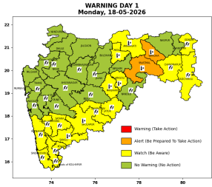 | 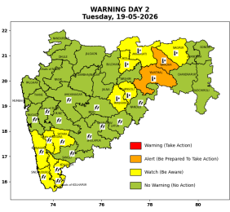 | 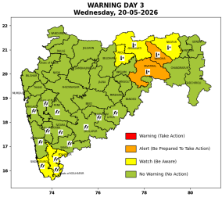 | 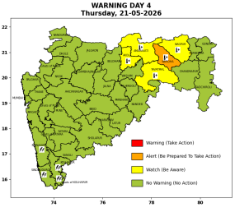 | 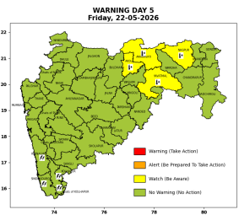

Pune, Lohegaon and Pashan observations at 0830 hrs. IST of Today
 | Temperature (°C) |  |  |  |  | Humidity (%) |  |  |  | Rainfall (mm)
 | Max.  past  24 hrs | Dep.  from  normal | Min.  past  24 hrs. | Dep.  from  normal | Dry  Bulb | At 0830 hrs. IST | Dep.  From  normal | At 1730  hrs. IST of y’day | Dep.  from  normal | Past  24 hrs. | Since  1st March | Dep.  from  normal
PNE | 39.2 | 2.3 | 24.0 | 0.6 | 29.4 | 55 | -5.0 | 32 | -6 | 0.0 | 92.8 | 64.4
PSN | - | - | 22.6 | - | 27.4 | 86 | - | - | - | 0.0 | - | -
LHG | 39.6 | 2.6 | 26.0 | 5.0 | 30.0 | 42 | -18.0 | 30 | -6 | 0.0 | 91.4 | 58.4

 |  |  |  |  |  |  | Local (Pune and neighbourhood) forecast
Max./Min. Temperature (°C) |  |  |  |  |  |  |  |  | Weather
Date | Pune | Pashan | Lohegaon | Chinchwad | Lavale | Magarpatta | NDA | Koregoan park
18/05/26 | 40 / 24.0* | 39 / 22.6* | 41 / 26.0* | 38 / | 38 / - | 42 / - | 39 / - | 40 / - | Mainly clear sky becoming partly cloudy sky towards afternoon or evening.
19/05/26 | 39 / 24 | 38 / 23 | 39 / 26 | 38 / 24 | 38 / 23 | 41 / 26 | 38 / 23 | 39 / 26 | Mainly clear sky becoming partly cloudy sky towards afternoon or evening.
20/05/26 | 38 / 24 | 37 / 23 | 39 / 26 | 37 / 23 | 38 / 23 | 40 / 26 | 38 / 23 | 39 / 26 | Mainly clear sky becoming partly cloudy sky towards afternoon or evening.
21/05/26 | 38 / 23 | 37 / 23 | 38 / 25 | 37 / 23 | 37 / 22 | 39 / 25 | 37 / 22 | 38 / 25 | Mainly clear sky becoming partly cloudy sky towards afternoon or evening.
22/05/26 | 37 / 23 | 36 / 22 | 38 / 25 | 37 / 23 | 37 / 22 | 39 / 25 | 37 / 22 | 38 / 25 | Mainly clear sky becoming partly cloudy sky towards afternoon or evening. Thunderstorm with lightening, very light rain very likely.
23/05/26 | 37 / 22 | 36 / 22 | 37 / 24 | 36 / 22 | 36 / 22 | 38 / 24 | 36 / 22 | 37 / 24 | Mainly clear sky becoming partly cloudy sky towards afternoon or evening. Thunderstorm with lightening, very light rain very likely.
24/05/26 | 36 / 22 | 36 / 22 | 37 / 24 | 36 / 22 | 36 / 22 | 37 / 23 | 36 / 22 | 37 / 24 | Mainly clear sky becoming partly cloudy sky towards afternoon or evening. Thunderstorm with lightening, very light rain very likely.
Rainfall Distribution |  |  |  |  | Rainfall Categories | Rainfall (mm) | Cloud condition |  | Rainfall Intensity | Range
Widespread (W) | 76-100% |  |  |  | Very Light rain | Trace to 2.4 mm | Mainly clear sky | 1-2 oktas | Light Spell | 1 cm/hr
 |  |  |  |  | Light rain | 2.5 to 15.5 mm | Partly cloudy sky | 3-4 oktas | Moderate Spell | 1-2 cm/hr
Fairly Widespread (FW) | 51 – 75% |  |  |  | Moderate rain | 15.6 to 64.4 mm | Generally cloudy sky | 5-7 oktas | Intense Spell | 2-3 cm/hr
Scattered (S) | 26 – 50% |  |  |  | Heavy rain | 64.5 to 115.5 mm | Overcast | 8 oktas | Very Intense Spell | 3-5 cm/hr
Isolated (I) | 1 – 25% |  |  |  | Very heavy rain | 115.6 to 204.4 mm |  |  | Extremely Intense Spell | 5-10 cm/hr
Dry (D) | No Rain |  |  |  | Extremely heavy rain | ≥ 204.5 mm |  |  | Cloudburst | > 10 cm/hr
Probability Terms in %: |  |  |  |  | Heavy snow | 6.5 to 11.5 cms water equivalent of rain
unlikely | < 25 |  |  |  | Very heavy snow | 11.6 to 20.4 cms water equivalent of rain
likely | between 25 50
very likely | between 51 75
most likely | >75
* = realized temperatu
Mumbai (Colaba) |  |  |  | Nagpur (AP)
Date 2026 | T max °C | T min °C | Weather | T max °C | T min °C | Weather
18/05/26 | 34 | 28 | Clear sky. | 44 | 29 | Partly cloudy sky .
19/05/26 | 33 | 27 | Clear sky. | 45 | 28 | Heat Wave.
20/05/26 | 33 | 28 | Clear sky. | 45 | 28 | Heat Wave.
21/05/26 | 33 | 27 | Clear sky. | 45 | 27 | Heat Wave.
22/05/26 | 33 | 27 | Clear sky. | 45 | 26 | Heat Wave.
23/05/26 | 33 | 28 | Clear sky. | 45 | 26 | Heat Wave.
24/05/26 | 33 | 28 | Clear sky. | 45 | 26 | Heat Wave.

